Amending carrier powers & immunities  
to support multi-technology rollouts of   
high-speed broadband

Consultation paper

12 June 2015

Disclaimer

The material in this consultation paper is of a general nature and should not be regarded as legal advice or relied on for assistance in any particular circumstance or emergency situation. In any important matter, you should seek appropriate independent professional advice in relation to your own circumstances.

The Commonwealth accepts no responsibility or liability for any damage, loss or expense incurred as a result of the reliance on information contained in this consultation paper.

This consultation paper has been prepared for consultation purposes only and does not indicate the Commonwealth’s commitment to a particular course of action. Additionally, any third party views or recommendations included in this consultation paper do not reflect the views of the Commonwealth, or indicate its commitment to a particular course of action.

Copyright

© Commonwealth of Australia 2015

cid:image001.jpg@01CF4DB8.C9F87BE0  The material in this consultation paper is licensed under a Creative Commons Attribution—3.0 Australia license, with the exception of:

* the Commonwealth Coat of Arms;
* this Department’s logo;
* any third party material;
* any material protected by a trademark; and
* any images and/or photographs.

More information on this CC BY license is set out at the creative commons website: [www.creativecommons.org/licenses/by/3.0/au/](http://www.creativecommons.org/licenses/by/3.0/au/). Enquiries about this license and any use of this consultation paper can be sent to: Market Structure Branch, Department of Communications, GPO Box 2154, Canberra, ACT, 2601.

**Attribution**

Use of all or part of this consultation paper must include the following attribution:

© Commonwealth of Australia 2015

**Using the Commonwealth Coat of Arms**

The terms of use for the Coat of Arms are available from the *It’s an Honour* website   
(see [www.itsanhonour.gov.au](http://www.itsanhonour.gov.au/) and click ‘Commonwealth Coat of Arms’).

Contents

1. Overview 4

2. Background 5

2.1. Carrier powers and immunities 5

2.1.1. Telecommunications Regulations 5

2.1.2. Low-impact facilities 5

2.2. National Broadband Network 6

2.3. Regulation Impact Statement 6

3. Proposed amendments 7

3.1. Telecommunications Regulations 7

3.2. Low-impact Facilities Determination 8

3.2.1. Section 1.3 – Definitions 9

3.2.2. Schedule Part 3 – Above ground housing 12

3.2.3. Schedule Part 4 – Underground facilities (for fixed-line networks) 12

3.2.4. Schedule Part 4A – Above ground facilities (for fixed-line networks) 13

3.2.5. Schedule Part 4B – Above ground hybrid fibre-coaxial facilities 17

4. How to make a submission 18

4.1. Publication of submissions 18

4.2. Release of submissions where authorised or required by law 18

4.3. Contact us 19

5. Glossary 20

# Overview

The Government is proposing to make amendments to telecommunications carrier powers and immunities to support the rollout of the multi-technology mix (MTM) National Broadband Network (NBN) and other next-generation broadband networks. The proposed amendments relate to the *Telecommunications Regulations 2001* (the Regulations) and the Telecommunications (Low-impact Facilities) Determination 1997 (LIFD).

The proposed amendments to the LIFD do the following:

* make definitions of fixed-line communications facilities in the LIFD technology neutral;
* provide for a small number of new types of facilities on an ongoing basis;
* allow thicker overhead communications cabling to be classed as low‑impact facilities;
* permit some facilities to be attached to the outside of multi‑unit buildings and allow some larger facilities to be installed inside multi-unit buildings;
* make earlier temporary amendments to the LIFD made on 30 March 2015 (and which came into effect on 2 April 2015) ongoing; and
* remove temporary geographic restrictions on the installation of HFC facilities in pilot areas.

These proposed amendments follow temporary amendments made in April 2015 to the LIFD to support the rollout of the NBN and other next-generation national broadband networks. These temporary changes allow NBN Co and other comparable carriers to more readily deploy high speed broadband technologies, connect premises, and locate and install equipment in multi-unit buildings. These temporary amendments to the LIFD were on a 12 month basis and were mostly limited to specified trial locations for the NBN MTM rollout, following a targeted consultation process. They were based on the premise that any proposals to allow the installation of these kind of facilities on an ongoing basis would be the subject of wide public consultation such as that provided for in this document.

The Department of Communications welcomes submissions on the proposed amendments in this consultation paper.

# Background

## Carrier powers and immunities

Schedule 3 to the *Telecommunications Act 1997* (the Act) provides carriers with powers to enter land (including buildings) for inspection, and to maintain and install certain types of facilities. It also provides certain immunities, including from a range of State and Territory laws (such as laws relating to land use, planning, design, constriction, siting, tenancy, environmental assessments and protection, collectively referred to as ‘planning laws’ in this paper), when carrying out those activities.

Schedule 3 supports the fast and efficient rollout of infrastructure by allowing it to be done nationally under a uniform streamlined process, rather than multiple state, territory and local government requirements. This helps carriers meet consumer demand for services while reducing the administrative burden on carriers and these tiers of government. Carriers exercising their powers under Schedule 3 must do so in accordance with obligations set out in the Act and the *Telecommunications Code of Practice 1997* (the Code).

Schedule 3 covers, among other things, the installation of low-impact facilities, which are specified in the LIFD. Schedule 3 does not provide powers and immunities if a facility does not belong to one of these classes. If Schedule 3 does not apply, carriers will need to comply with applicable State and Territory planning laws and obtain landowner consent.

### Telecommunications Regulations

In accordance with clause 3 to Schedule 3 of the Act, a ‘designated overhead line’ (essentially overhead cabling) cannot be installed using carrier powers and immunities if it is of a diameter greater than 13 millimetres (mm) unless another distance is specified in the Regulations. Currently, the maximum diameter specified in the Regulations for this purposes is 30mm in diameter. This maximum diameter is reflected in the LIFD to allow carriers to install overhead cabling up to this size as low-impact facilities.

### Low-impact facilities

Low-impact facilities are designated by the Minister for Communications in the LIFD. They include some radiocommunications facilities, underground and above-ground housing, underground and some aerial cables, public payphones, emergency and co-located facilities.

The types of facilities that are specified in the LIFD as low-impact are those considered to be essential to the effective and efficient operation of telecommunications networks in providing services to the public, but are considered to be of low visual impact and unlikely to cause significant disruption to the community during installation or operation.

This approach to the specification of low-impact facilities encourages carriers to roll out networks using components that fall within strict type, size, colour and location limitations, thereby minimising the impact of telecommunications infrastructure on the community generally while expediting the supply of services.

Schedule 3 to the Act requires carriers to notify land owners and occupiers of intended activities enabled by the LIFD. Land owners may object to proposed activities. The Code requires carriers to make reasonable efforts to resolve valid objections from land owners or occupiers. If the land owner or occupier is not satisfied with the carrier’s proposed resolution, and no agreement can be reached, they may ask the carrier, in writing, to refer the objection to the Telecommunications Industry Ombudsman (TIO) for resolution if the carrier wishes to continue with the activity. The carrier must comply with the request to refer the matter to the TIO. Carriers must comply with any direction made by the TIO.

When using carrier powers and immunities, Schedule 3 also requires carriers to act in accordance with good engineering practice, protect the safety of people and property, interfere with other users of the land as little as practicable, and protect the environment.

Facilities to be installed in areas of environmental significance—including those listed under Commonwealth, State or Territory heritage registers—cannot be low-impact facilities and would otherwise be subject to other Commonwealth, State or Territory approval processes. Facilities remain subject to other Commonwealth laws which would ordinarily apply, such as the *Environment Protection and Biodiversity Conservation Act 1999* (Cth).

## National Broadband Network

The Australian Government is committed to the delivery of better broadband to Australians and is doing this through the rollout of the NBN. The Strategic Review of the NBN in December 2013 recommended that the NBN should be completed using a multi-technology mix to deliver fast broadband sooner and at less cost to taxpayers. In light of this, the Government issued a new Statement of Expectations to NBN Co Limited (NBN Co) on 8 April 2014. The Statement instructs NBN Co to build the network in a cost-effective way using the technology best matched to each area of Australia.

The Strategic Review identified technologies that may be used by NBN Co include fibre-to-the-node (FTTN), fibre-to-the-premises (FTTP), fibre-to-the-basement (FTTB), hybrid fibre-coaxial (HFC), fixed wireless and satellite. NBN Co continues to rollout FTTP, fixed wireless and satellite, has commenced the rollout of FTTB, and is currently trialling FTTN and HFC deployments.

In 2011, the Regulations and the LIFD were amended to support the rollout of FTTP by NBN Co and other carriers operating on a comparable basis. That is, carriers proposing to operate a national network used (or for use) for the high speed carriage of communications, on a wholesale-only and non-discriminatory basis. The proposed amendments will be available to carriers on a similar basis.

## Regulation Impact Statement

The Office of Best Practice Regulation has advised that a Regulation Impact Statement is not required because the proposal is a consequence resulting from earlier substantive policy announcements, that is, the Government’s decision to move to a MTM approach. The Department of Communications will self-assess the regulatory cost savings resulting from these amendments.

# Proposed amendments

The Government proposes amendments to the Regulations ([Appendix A](http://www.communications.gov.au/__data/assets/pdf_file/0006/245049/June_2015_Consultation_Draft_-_Telecommunications_Regulations_Amendments_-_Appendix_A.pdf)) and the LIFD ([Appendix B](http://www.communications.gov.au/__data/assets/pdf_file/0005/245048/June_2015_Consultation_Draft_-_Low-Impact_Facilities_Determination_-_Appendix_B.pdf)) to facilitate the rollout of the MTM NBN and other comparable networks. The proposed amendments would be made on an ongoing basis, but it is intended that they would be reviewed by Government in the future (e.g. once the NBN is built and fully operational).

## Telecommunications Regulations

Under Clause 3 of Schedule 3 to the Act, overhead cables in excess of 13mm in diameter cannot be specified as a low-impact facility unless a larger diameter is specified in the Regulations.

In 2011, the Regulations were amended, in effect, to allow overhead cables of up to 30mm and the LIFD was amended to allow optical fibre cabling of up to that diameter. In the move to a MTM approach, in some limited circumstances overhead cabling of up to 48mm will be required, specifically in the HFC network. The Government therefore proposes to amend the Regulations to allow this.

Specifically, the Government proposes to recommend to the Commonwealth Governor-General that Regulation 11.2 be amended to increase the diameter of ‘designated overhead line’ from 30 mm to 48mm. This change would then allow the Minister for Communications to specify overhead cabling of up to 48mm in diameter as low-impact in the LIFD. Such cabling is specified at Item 1 of Part 4A of the Schedule to the LIFD.

NBN Co and comparable carriers are expected to use the smallest cable and cable bundle diameter feasible for above ground line links in an area. NBN Co has advised that in some areas, particularly in HFC areas, it will be necessary to add a cable to an existing overhead cable or a bundle of overhead cables to improve the network. This includes piggy-backing new cables on to existing cables and cable bundles in order to transit through existing coverage areas to reach areas that were missed during previous HFC network rollouts.

In limited circumstances, such as when NBN Co adds an extra cable to an existing 42mm bundle, the diameter of the HFC cable bundle will be 48mm. Typically, HFC cable bundles will be much smaller than this. In addition, NBN Co has advised that in very limited circumstances, individual copper cables of up to 40mm in diameter will need to be used to augment the copper network for FTTN. Further guidance on the limited use of such cabling will be provided in the Explanatory Statement to the amending Determination and other documents as required.

In the past there have been community concerns about the use of overhead cabling for telecommunications. The Government appreciates these concerns but believes that there are important countervailing factors that also need to be considered. Telecommunications cabling is placed on above ground infrastructure for electricity that already exists and to which people are generally accustomed. In large part the additional cabling that is proposed by NBN Co will augment existing cabling (i.e. a cable will be added to an existing bundle); the overall amount of new cabling will be limited; and cabling in new locations (i.e. where there are overhead power cables but no overhead telecommunications cables) will be small in diameter. As a result, any impact is expected to be limited. On the other hand, the cabling will be used to provide significantly better broadband services, services for which there is strong community demand.

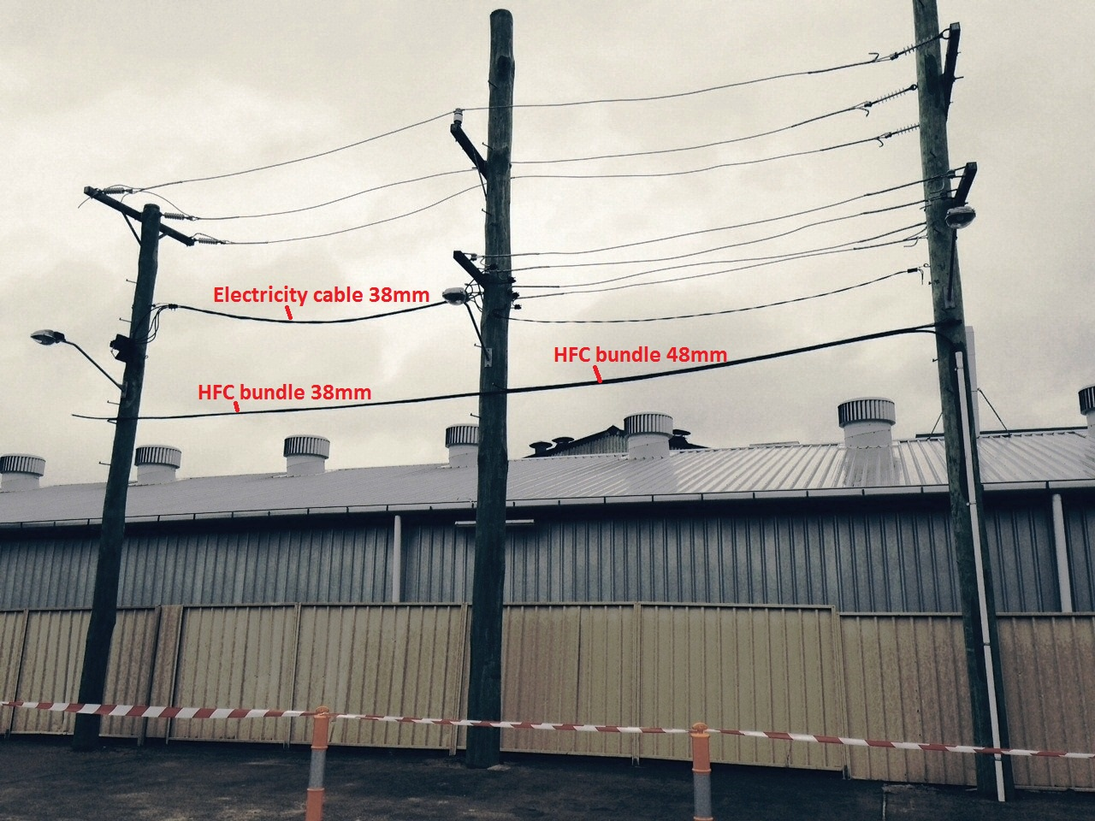The following photo gives an indication of the visual impact of the thickest possible cable bundle relative to existing types of cable bundles***.***

## Low-impact Facilities Determination

The proposed amendments to the LIFD do the following:

* make definitions of fixed-line communications facilities in the LIFD technology neutral;
* provide for a small number of new types of facilities on an ongoing basis;
* allow thicker overhead communications cabling to be classed as low‑impact facilities;
* permit some facilities to be attached to the outside of multi‑unit buildings and allow some larger facilities to be installed inside multi-unit buildings;
* make earlier temporary amendments to the LIFD from April 2015 ongoing; and
* remove temporary geographic restrictions on the installation of HFC facilities in pilot areas.

In 2011, amendments were made to the LIFD to support the rollout of FTTP networks. Now that a MTM approach has been adopted for the NBN, facilities for many different types of fixed-line broadband technologies need to be included in the LIFD. The Government is therefore proposing amendments to the LIFD to use technology neutral language to describe particular above ground and underground ground fixed-line communications facilities. This will enable carriers to deploy the most cost‑effective technology on a case-by-case basis subject to generic rules, similar to those already in place for the deployment of FTTP facilities in certain instances.

Unless otherwise indicated below, the facilities to be added to the LIFD may only be installed by carriers operating a national network for the high speed carriage of communications on a wholesale‑only and non‑discriminatory basis. As such, the amendments would benefit NBN Co, but they would also be available to other carriers meeting these criteria.

Volumetric limits on the size of facilities listed below refer to ***substantive volume***. This term is defined in the current LIFD as the size of a facility measured in three dimensions, without including the size of any ancillary fixings, protrusions, or other attachments of an incidental nature in this calculation[1]. This can be compared to the displacement volume of the facilities, which is not what substantive volume refers to. The volume limits include a ten percent margin in addition to the presently largest known equipment size currently known.

### Section 1.3 – Definitions

The proposed amendments seek to use generic, technology neutral language to define fixed-line communications facilities, so that facilities for optical fibre, HFC, FTTN, FTTB and future fixed-line technologies are covered by the LIFD. Readers should also consult the proposed amendments to the Schedule to the LIFD to understand the full details of the proposed new items.

#### Proposed amendment 1 – access terminal

Proposed amendment 1 would add the technology neutral term, ***access terminal***. This termwouldreplace the technology specific term, ***optical fibre access terminal***. An access terminal is a connection device that allows a line link (for example, in a street) to be connected to a drop cable, which connects a premises.

#### Proposed amendment 2 – amplifier

Proposed amendment 2 would add the technology neutral term, ***amplifier***.

#### Proposed amendment 3 – building connection equipment

Proposed amendment 3 would remove the definition of ***building connection equipment***. This term would be replaced by the following: ***external building connection equipment*** and ***internal building connection equipment***. It is necessary to list these as separate facilities because different volumetric limits are proposed for indoor and outdoor installation.

#### Proposed amendment 4 – designated installation period & drop cable

Proposed amendment 4 would remove the definition of ***Designated Installation Period***, which was added in the temporary amendments to the LIFD in April 2015. It is intended that these types of facilities will be able to be installed on an ongoing basis, rather than limited to a 12 month period, as had been implemented by the April 2015 amendments.

This amendment would also add the technology neutral term, ***drop cable***. This replaces the technology specific ***optical fibre drop cable***.

#### Proposed amendment 5 – HFC trial region & external building connection equipment

Proposed amendment 5 would remove the definition of ***HFC Trial Region*** which was added in the temporary amendments to the LIFD in April 2015. Its removal is consistent with the amendments being put in place on an ongoing basis and applying in all areas of Australia.

This amendment would also add the term ***external building connection equipment***. This is a facility that is installed on, or attached to an external wall or other exterior surface of a multi-unit building, which is used, or is intended for future use by end users located in the building or a related building nearby.

This change would make the temporary amendments made in April 2015 to permit building connection equipment to be installed on the outside of buildings ongoing. Inclusion of this type of facility is necessary as older style apartment complexes (for example, those without basement parking or a communications room) may not have enough suitable internal space to install building connection equipment necessary for FTTB deployments. As a result, critical equipment may need to be installed outside the building in some instances.

As a matter of general industry practice, it is expected that where there is space inside a multi-unit building for the equipment, it would be installed in that interior location.

An example of this type of facility would be a micronode enclosure that houses FTTB equipment, which is attached to the outside of a multi-unit building for use by end-users located inside the building, or a nearby building.

External and internal building connection equipment are being listed as separate facilities because different volumetric limits are proposed (see proposed amendment 7 below).

#### Proposed amendment 6 – IEEE 1222-2011 standard

Proposed amendment 6 would remove the definition of ***IEEE 1222-2011 Standard***, which was used in defining optical fibre cabling, but is no longer needed in the technology neutral approach.

#### Proposed amendment 7 – internal building connection equipment

Proposed amendment 7 would add the term ***internal building connection equipment***. This is a facility that is installed in, or attached to, any interior part of a multi-unit building, which is used, or is intended for future use by end users located in the building or a related building nearby.

An example of this type of facility would be a micronode enclosure or a rack cabinet that houses FTTB equipment, which is installed inside a multi-unit building for use by end-users located inside the building, or a nearby building. It permits similar facilities to those permitted by ***in‑building subscriber connection equipment*** when installed by NBN and comparable carriers, but additionally allows the installation to occur inside a building near the building or buildings in which subscribers are located.

#### Proposed amendment 8 – network termination device

Proposed amendment 8 would remove the definition ***network termination unit*** and replace it with ***network termination device***. This is a technology neutral term that is used to describe devices that terminate a carrier’s network and provide a connection point between a carrier’s network and customer cabling or customer equipment such as a router.

#### Proposed amendment 9 – access terminal

Proposed amendment 9 would remove the definition ***optical fibre access terminal*** which is replaced by the technology neutral term ***access terminal*** (see proposed amendment 1 above).

#### Proposed amendment 10 – drop cable & optical node

Proposed amendment 10 would remove the definition ***optical fibre drop cable*** which is replaced by the technology neutral term ***drop cable*** (see proposed amendment 4 above).

This amendment would also add the term ***optical node*** which is used in high speed fixed-line communications networks including HFC and FTTN. It is used to convert between optical and electrical signals along cables.

#### Proposed amendment 11 – splice enclosure

Proposed amendment 11 would remove the definition ***optical fibre splice enclosure*** which is replaced by the technology neutral term ***splice enclosure*** (see proposed amendment 15 below).

#### Proposed amendments 12 & 13 – termination boxes

Proposed amendments 12 and 13 would remove the definitions ***optical fibre termination box (Type A)*** and ***(Type B)*** which are replaced by the technology neutral term ***premises connection device*** (see proposed amendment 14 below).

#### Proposed amendment 14 – power supply & premises connection device

Proposed amendment 14 would broaden the definition of ***power supply***. The expanded definition would cover equipment that provides power for fixed-line networks when deployed overhead. An example of this type of facility would be a HFC power supply unit used to power optical nodes and amplifiers attached to a public utility pole.

This proposed amendment would also add the technology neutral term, ***premises connection device***, which replaces ***optical fibre termination box (Type A)*** and ***(Type B)***. A premises connection device is a device used to terminate a drop cable from the network at a premises for connection to in-building cabling or equipment at the premises. It is typically a small box attached to the outside of a building.

#### Proposed amendment 15 – splice enclosure

Proposed amendment 15 would add the technology neutral term, ***splice enclosure***, which replaces ***optical fibre splice enclosure***. A splice enclosure attaches line links to drop cables, other line links or access terminals.

#### Proposed amendment 16 – underground network equipment

This proposed amendment would add the generic, technology neutral definition ***underground network equipment*** to cover most facilities that are part of a network for the high speed carriage of communications and placed in underground pits and conduit.

### Schedule Part 3 – Above ground housing

The following proposed amendments would change or add new items in Part 3 of the Schedule to the LIFD which deals with above ground housings. This includes increasing the volumetric limit for some facilities.

#### Proposed amendment 17 – external building connection equipment

Proposed amendment 17 would add the new facility ‘external building connection equipment’, defined in proposed amendment 5, to the Schedule of the LIFD. As explained above, the equipment provides a service to either end-users within the multi-unit building to which the equipment is attached, or end-users who are located in another nearby multi-unit building.

The maximum permissible substantive volume for this facility would be 0.59 cubic metres. This permits the installation of equipment such as micronode enclosures for FTTB rollouts. Such an enclosure could, for example, measure 1940mm x 770mm x 790mm.

#### Proposed amendment 18 – internal building connection equipment

Proposed amendment 18 would add the new facility ***internal building connection equipment***, defined at proposed amendment 6 to the Schedule of the LIFD. As explained above, the equipment provides a service to either end-users within the multi-unit building in which the equipment is installed, or end-users who are located in another nearby multi-unit building.

The maximum permissible substantive volume for this facility is proposed to be 1.3 cubic metres. This permits the installation of equipment such as FTTB rack cabinets. Such a cabinet could, for example, measure 1360mm x 1040mm x 380mm. Schedule 3 of the Act requires carriers to act in accordance with good engineering practice, protect the safety of people and property, interfere with other users of the land as little as practicable, and protect the environment. Carriers are expected to use the smallest equipment feasible for the available space inside each building, and to install facilities inside dedicated communications rooms whenever possible.

#### Proposed amendment 19 – in-building network equipment

Proposed amendment 19 would move in-building network equipment to Item 10 in Part 3 of the Schedule, and would increase the maximum permissible substantive volume for this facility to 1.3 cubic metres.

This equipment covers a broad class of equipment deployed in a multi-unit building for a purpose other than directly supplying carriage services to end-users. This could include providing services to non‑addressable locations in the future (e.g. traffic lights, bus stops, and private payphones). Given the need to cover a wider range of operational scenarios, the permissible volume of such equipment needs to be increased. The maximum permissible substantive volume of 1.3 cubic metres matches that for internal building connection equipment, because the same equipment may need to be under this category of facility.

### Schedule Part 4 – Underground facilities (for fixed-line networks)

#### Proposed amendments 20, 21, 22

Proposed amendments 20, 21 & 22 replace existing fibre-specific underground facilities with a single generic, technology neutral category of facilities, so that underground facilities for optical fibre, HFC, FTTN, FTTB, and any future fixed-line broadband technologies are included in the LIFD. The amendments combine the following existing items of Part 4 of the Schedule:

* Item 4 (underground optical splice enclosure);
* Item 5 (underground optical fibre access terminal); and
* Item 6 (underground hybrid fibre-coaxial network equipment)

If the planned technology neutral approach is implemented, the above types of equipment would not need to be specified as separate facilities.

Because such facilities are located underground, they have little or no visual impact, and their installation in existing pits and conduits causes minimal disturbance to the community.

The maximum substantive volume of this proposed new facility type is 0.23 cubic metres. Some examples of this facility type include optical nodes, amplifiers, and access terminals.

### Schedule Part 4A – Above ground facilities (for fixed-line networks)

#### Proposed amendment 23

Proposed amendment 23 would replace existing above ground fibre-specific facilities with generic, technology neutral ones so that overhead facilities for optical fibre, HFC, FTTN, FTTB, and any future fixed-line technologies are included in the LIFD, and are covered by one part of the schedule. Currently, such facilities are split between Parts 4A and 4B. The new approach will make it easier for industry and the public to understand the rules for these facilities, and aid carrier compliance.

Because of the breadth of the changes, the amendment would omit the existing Part 4A and replace it with a new one. The proposed amendments would combine existing facilities listed in Part 4A, ‘Above ground optical fibre facilities’, and the facilities listed in Part 4B, ‘Above ground hybrid fibre-coaxial facilities’, as a result of the temporary amendments to the LIFD in April 2015.

All of the facilities listed in proposed replacement Part 4A are would only be low-impact facilities if they are, or are to be, part of a national network used, or for use, for the high speed carriage of communications, on a wholesale-only and non-discriminatory basis. Carriers that are unable to meet these criteria must seek approval under relevant State and Territory laws to install such facilities.

Like all facilities listed in the LIFD, these facilities are not low-impact when carriers intend to install them in areas of environmental significance, as defined in the LIFD. Carriers cannot use the LIFD to install facilities in such areas, and must seek approval under relevant Commonwealth, State and Territory planning laws.

Powers under Schedule 3 will help with the installation of the facilities on utility distribution network infrastructure such as power poles. Carriers installing facilities using Schedule 3 powers and immunities must, among other things, comply with requirements at clause 12 of Schedule 3 in the Act. Specifically, the installation must meet relevant industry standards, including any applicable standards for the installation of telecommunications facilities on public utility infrastructure. In addition, carriers must make reasonable efforts to enter into agreements with public utilities when engaging in activities that are likely to affect the operations of the utility, such as installing facilities on their infrastructure, as required by clause 11 of Schedule 3 in the Act.

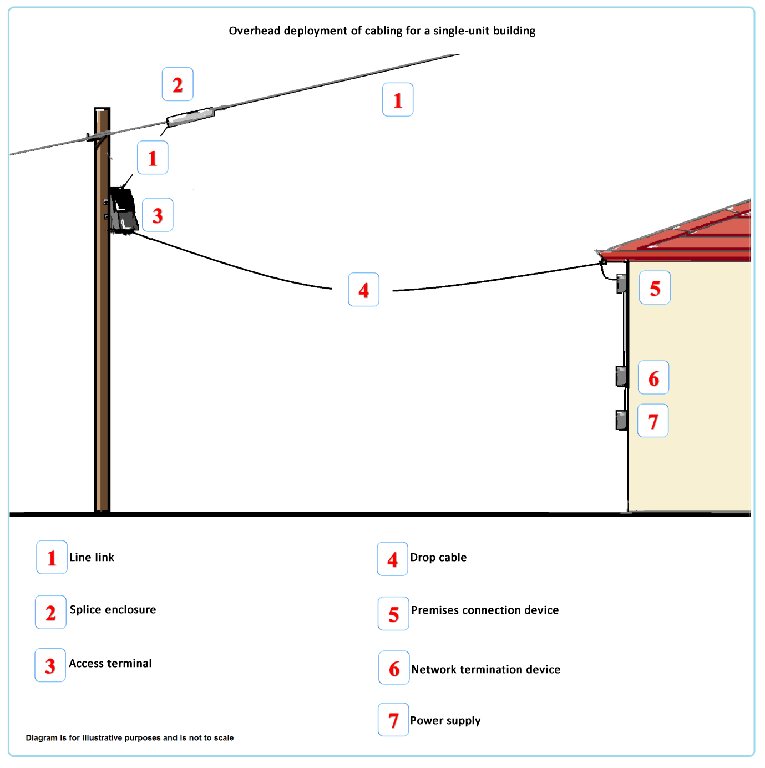To help explain the proposed amendments, the following diagram illustrates an overhead fixed-line network installation to serve a single‑unit building.

##### Proposed item 1 – line link/s

Proposed item 1 covers the aerial deployment of telecommunications cabling. Specifically, Item 1 covers above ground line links (single or bundles) deployed or attached to a public utility structure, building or other structure. This item is intended to cover the distribution component of an above ground fixed-line network and is separate to drop cables. Consistent with the proposed amendment to regulation 11.2 of the *Telecommunications Regulations 2001*, the maximum permissible external cross-section of any single line link or cable bundle would be specified as 48 mm. This facility type is analogous to the optical fibre line link in a FTTP deployment, which is permitted in the current version of the LIFD, however, the permitted diameter is greater.

While it is expected that generally a single overhead cable would be strung between poles in any one location, to provide flexibility the instrument does not prevent two or more overhead cables in any one location. If two or more communications cables are bundled, the bundle as a whole, not the individual cables would need to be within the maximum permissible external cross-section, which is proposed to be amended to 48 mm.

NBN Co and comparable carriers are expected to use the smallest cable diameter feasible for above ground line links in an area. It is therefore expected that there will not be widespread overhead deployment of 48mm cabling. For example, as described in the proposed amendments to the Regulations above, it will be used in limited circumstances to improve capacity on networks where existing cabling exists.

These provisions do not permit carriers to install new additional structures such as poles to support overhead cabling without seeking development approval under relevant State and Territory planning laws.

Additionally, clause 51 of Schedule 3 of the Act requires carriers to remove overhead lines installed using carrier powers and immunities in the event that all of the non-communications cables such as electricity cables are permanently removed from the poles they are attached to.

##### Proposed item 2 – optical node

Proposed item 2 would cover optical node devices. They convert optical signals to electrical signals for transmission over cables, and electrical signals to optical signals for transmission over cables. The device is usually clamped to, strung from, or otherwise mounted on, a cable or structure.

The maximum permissible volume for an optical node device is proposed to be 0.21 cubic metres. This facility type is usually enclosed in a rectangular shaped container.

##### Proposed item 3 – splice enclosure

Proposed item 3 would cover splice enclosures. These are devices in which a line link is spliced to another line link, an access terminal or a drop cable. They are used in connecting premises to the main cabling of a communications network to a premises. The device is usually integrated with a cable or clamped to, strung from, or otherwise mounted on, a cable or structure.

The maximum permissible volume for a splice enclosure is proposed to be 0.046 cubic metres. This facility type is analogous to the optical fibre splice enclosure in a FTTP deployment, which is permitted in the current version of the LIFD.

##### Proposed item 4 – access terminal

Proposed item 4 would cover access terminals. An access terminal is a connector device that allows a line link to be connected to a drop cable. Some examples of this type of facility are an HFC tap or a cross‑connect for copper cables. The device is usually clamped to, strung from, or otherwise mounted on, a cable or structure.

The maximum permissible volume for an access terminal is proposed to be 0.035 cubic metres. This facility type is analogous to the optical fibre access terminal in a FTTP deployment, which is permitted in the current version of the LIFD.

##### Proposed item 5 – drop cable/s

Proposed item 5 would cover a single aerial drop cable or a bundle of aerial drop cables. These cables are lead-ins used to connect the main distribution cabling of the network to the premises. The maximum permissible external cross-section of a drop cable would be 13 mm (consistent with the current approach), where the drop cable is attached to a single-unit building, and 30 mm, when attached to a multi-unit building. They are analogous to optical fibre drop cables in an FTTP deployment, which is permitted in the current version of the LIFD. The technology neutral approach used here will enable other types of drop cables to be used including coaxial and copper.

If two or more overhead drop cables are bundled, the bundle as a whole, not the individual cables, would need to be within the maximum permissible external cross-section of 13mm.

##### Proposed item 6 – premises connection device

Proposed item 6 would cover above-ground facilities used to connect drop cables to premises, similar to the device already used to connect fibre lead-in cables to premises in FTTP areas. Basically it is a rectangular enclosure attached to the exterior of a premises, in which a connector and any spare cable can be housed.

As the box can store the end of a drop cable, including any pre-installed connector and spare cable, pending the provision of a service, it is not necessary for the actual occupant of the building at which the box is installed to actually be, or intending to be, a subscriber to a telecommunications service supplied by means of the facility.

The maximum permissible substantive volume for the premises connection devices installed is proposed to be 0.04 cubic metres. This facility type includes but is not limited to square and rectangular shapes.

##### Proposed item 7 – network termination device

Proposed item 7 would cover network termination devices (NTDs). These are devices that terminate a carrier’s network and provide a connection point between a carrier’s network and customer cabling or customer equipment such as a router. The new definition is intended to be technology neutral.

The inclusion of NTDs is intended to facilitate their installation where it is required on the outside of buildings or in other publicly accessible areas. NTDs are often installed inside premises, including residences. While inclusion in the LIFD would technically allow installation of such devices without the consent of the owner and/or occupier, in reality, the installation of an NTD in a premises would require a customer to order a service and give their consent to the installation of an NTD.

The maximum permissible substantive volume for network termination devices is proposed to be 0.02 cubic metres. This facility type is analogous to the network termination unit in a FTTP deployment, which is permitted in the current version of the LIFD.

##### Proposed item 8 – power supply

Proposed item 8 would cover power supply equipment. They are cabinets that are installed above ground, typically mounted on a utility pole, or are attached to a building or other structure. The cabinets contain a transformer that steps down mains voltage and injects this power into cable, which is used to power equipment that is part a communications network. Equipment powered by a power supply includes NTDs, optical nodes and amplifiers. The cabinets may contain backup batteries to maintain service for a limited period in the event of a power outage.

Where power supply equipment is connected to an NTD, the maximum permissible substantive volume for this facility is 0.005 cubic metres. Where it is connected to an optical node or amplifier, the maximum permissible substantive volume for this unit is proposed to be 0.15 cubic metres. This facility could, for example, measure 622mm x 615mm x 355mm.

##### Proposed item 9 - amplifier

Proposed item 9 would cover amplifiers. These are devices which amplify the signal strength on a cable. The maximum permissible substantive volume for the specified amplifier is proposed to be 0.02 cubic metres. This facility type is usually enclosed in a rectangular shaped container. These items are typically clamped to, strung from or mounted on a cable or other structure (such as a pole).

##### Proposed item 10 – auxiliary network equipment

Proposed sub-item 10 (a) would cover devices such as directional couplers and line splitters which connect, isolate or split a cable. They allow signals to be shared across multiple cables. Sub-item 10 (b) would cover devices such as line power inserters and equalisers which inject power into cable, or balance the distribution of power and radio frequency budget of a network or actively manage the operational elements of a network.

These facilities are usually affixed to a cable or other structure. The maximum permissible volume for auxiliary network equipment is proposed to be 0.002 cubic metres. This facility could, for example, measure 122mm x 145mm x 86mm.

### Schedule Part 4B – Above ground hybrid fibre-coaxial facilities

#### Proposed amendment 24

Proposed amendment 24 would remove existing Part 4B of the Schedule to the LIFD, which provides for the installation of HFC facilities on a trial basis in HFC Trial Regions. It is no longer required if the technology neutral approach proposed (and outlined above) is adopted on an ongoing basis.

# How to make a submission

The Department of Communications welcomes views on the proposed amendments. Submissions should make reference to specific amendment numbers where relevant. Submissions should be made:

By email: [powersandimmunities@communications.gov.au](mailto:powersandimmunities@communications.gov.au?subject=Consultation%20Paper%20Submission)

By mail: Director

Construction Policy

Market Structure Branch

Department of Communications

GPO Box 2154

CANBERRA ACT 2615

Submissions should be lodged by Friday 10 July 2015.

Submissions should also identify:

* the name of the party making the submission
* the organisation represented (if applicable)
* contact details, including telephone number, postal and email address.

## Publication of submissions

In general, the Department publishes submissions it receives. The Department will not publish a submission or part of a submission if the Department considers such material to be defamatory or otherwise unlawful or to be unsuitable for any other reason.

The Department prefers to receive submissions that are not claimed to be confidential. However, the Department accepts that a submitter may sometimes wish to provide information in confidence. In these circumstances, submitters are asked to identify the material over which confidentiality is claimed and provide a written explanation for the claim.

The Department will consider each confidentiality claim on a case-by-case basis. If the Department accepts a claim, it will not publish the confidential information unless authorised or required by law to do so.

The Department will not acknowledge submissions.

## Release of submissions where authorised or required by law

Any submissions provided to the Department may be released under the *Freedom of Information Act 1982* (unless an exemption applies) or shared with other Commonwealth Government agencies or certain other bodies. The Department may also be required to release submissions for other reasons including for the purpose of parliamentary processes or where otherwise required by law (for example, under a court subpoena). While the Department seeks to consult submitters of confidential information before that information is provided to another party, the Department cannot guarantee that confidential information will not be released through these or other legal means.

## Contact us

For further information about the carrier powers and immunities regime or the proposed amendments in this Consultation Paper, please contact the Department of Communications using the email address above or by phoning the Director, Construction Policy, on 02 6271 1000.

# Glossary

**ACMA -** Australian Communications and Media Authority – the telecommunications-specific industry regulator dealing with carrier powers and immunities issues

**Act -** *Telecommunications Act 1997*

**Carrier -** A person licensed under the Telecommunications Act to own and operate telecommunications facilities and who has powers and immunities to install such facilities

**Code -** *Telecommunications Code of Practice 1997*

**FTTB -** Fibre to the basement – an access technology using optical fibre to a building’s basement and then copper to premises to provide high-speed services to multi-unit buildings

**FTTN** **-** Fibre to the node – an access technology using optical fibre to a node on the street and then copper to provide high-speed services to premises

**FTTP** **-** Fibre to the premises – an access technology using optical fibre only to provide high-speed services to premises

**HFC -** Hybrid fibre coaxial cable – an access technology conceived and built for pay TV which uses fibre to a node and coaxial cable to provide high-speed services to premises

**LIFD** **-** Telecommunications (Low-impact Facilities) Determination 1997

**MTM -** Multi-technology mix, a network deployment strategy which uses the most cost-effective of a range of access technologies to provide high-speed broadband to premises

**NBN -** National Broadband Network – a high speed broadband network being constructed for the Australian Government by NBN Co.

**NBN Co -** NBN Co Limited - the Government-owned company constructing and operating the NBN

**NTD -** Network termination device – a device that terminates a carrier’s network and provides a connection point between a carrier’s network and customer cabling or customer equipment

**Power and immunities** – Rights confirmed on carriers under Schedule 3 of the Telecommunications Act enabling them to inspect land and install and maintain certain types of telecommunications facilities

**Regulations** **-** *Telecommunications Regulations 2001*

**Schedule 3** - The part of the Telecommunications Act setting out carrier powers and immunities

**TIO** **-** Telecommunications Industry Ombudsman – the independent dispute resolution service for telecommunications consumers, including some powers and immunities issues

1. For further explanation of this term see the explanatory statement at [www.comlaw.gov.au/Details/F2011L02696/Explanatory%20Statement/Text](http://www.comlaw.gov.au/Details/F2011L02696/Explanatory%20Statement/Text) for the *Telecommunications (Low-impact Facilities) Determination 1997 (Amendment No. 1 of 2011)*.